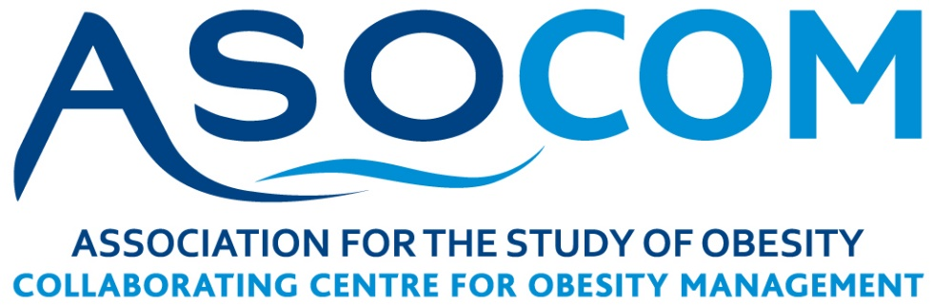

ASO UK Centres for Obesity Management Network
Invitation and Application Form
The ASO is establishing a network of Centres for Obesity Management (Adult COM’s) aimed at strengthening and advancing the evidence base, improving practice and influencing policy for the management of obesity in adults within the UK.
Who should join?
The ASO UK Adult COM network includes members working within Tier 2, Tier 3 and Tier 4 adult obesity services delivered across a range of NHS and non NHS settings. Each service is involved in working towards improving the management of adults with obesity.
Establishing a UK COMs Network
In order to realise the objectives of the ASO, it is proposed to establish a UK network for those involved in research and/or providing services for adults with obesity with the aim to:

- Implement state-of-the art evidence-based care for patients with obesity
- Facilitate communication and networking between ASO’s clinical practitioners, researchers, policy-makers and industry with the aim to improve the management of obesity
- Promote multidisciplinary research collaborations and research projects
- Deliver clinical education as part of a multi-disciplinary approach to obesity management in the form of workshops at the UKCO and annual national training courses
- Contribute to consultations, practice guidance and position statements on key UK treatment issues
- Provide evidence-based input of the UK perspective at a European and international level through EASO and WOF.

It is proposed that COM’s members will be supported by ASO Trustees to develop the following activities:

- 2 Day ASO Multidisciplinary national training course: Delivered by ASO members including experts involved in the COM’s network.

- UK COMs workshop: Topic specific interactive workshops delivered by COMs members for clinical practitioners and researchers with the aim to improve the management of obesity and strengthen the evidence-base.

- UK COMs Summit: An annual high level meeting which convenes the leaders and key staff from each Centre will take place as a pre or post-satellite event linked to the 2 day UKCO event with the aim of sharing good practice; key research; developing collaborations to advance the evidence-base.
If you are interested in joining the COM’s network and being integral to these exciting developments aimed at strengthening and advancing the evidence-base, improving practice and influencing policy for adult obesity management, please complete the form below to register your interest. Please use people first language.

Eligibility Criteria: At least one member of your team/service is required to be a Full ASO member

ASO UK COM’s Network Registration Form
Name of Institution:
Address:
Town/City:
Country:
Website:
Lead Contact:
Position of Lead Contact:
Member of ASO
Telephone:
Email:
Signature of Lead Contact:
Date of Submission:

General Information
Patients: Outline patient profile. | Number of patients with obesity seen per annum
 | Number of new patients with obesity per annum
 | Number of patients with BMI > 40 per annum
Facility Location: Outline facilities and geographical distribution of sites. | Is the service a Tier 2, Tier 3, Tier 4 service?
 | - within a university hospital
 | - within a general hospital
- within a larger department (internal medicine, endocrinology...)
If yes, please give details.
 | - Within primary care
 | Number of beds dedicated to obesity
 | Number of weekly clinics dedicated to obesity
Staff Specifications: Give overview of all staff involved in the delivery of the Obesity Management service. | Number in Whole Time Equivalent (WTE) of physicians involved in obesity management
 | Number in WTE with World Obesity Federation SCOPE certification
 | Number in WTE of Dietitians
 | Number in WTE of Psychologists/Psychiatrists
 | Number in WTE of Obesity Specialist Nurses
 | Number in WTE of Physical educators/physiotherapists
 | Anyone else? If yes, please give details.

